Home Me/School Me Poster Template

Instructions
Have students create drawings that answer the questions in the prompts. For each prompt, have students select a word that describes him/her. Prepare posters for each student by writing out the prompts at the bottom of the poster, allowing enough space for drawings to depict the idea (e.g., a drawing of them at home being silly, a drawing of them being quiet, etc.). At the end, have each student write in his/her response in the blank to the best of their ability. Underneath it, print the word they selected.
Home Me  (photo or drawing from home) | School Me  (photo or drawing at school)
I am a _silly_ kid at home.  (example: quiet, loud, silly, happy, glad, sad, scared, angry, nervous, excited, tired) | 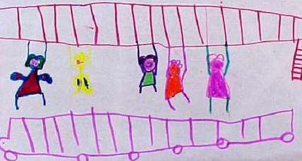  I am a playful kid at school.  (example: quiet, loud, silly, happy, glad, sad, scared, angry, nervous, excited, tired, playful)
At home I like to __________. | At school I like to _____________.
At home I have to ______________.  (think of chores he/she has to do, or personal body care (take a bath, brush my teeth) | At school I have to ____________.  (think of behaviors or class expectations, e.g. share, listen, raise my hand)
(Optional: Have the students pick what they would like to contrast to being at school and home.) | (Optional: Have the students pick what they would like to contrast to being at school and home.)
Optional ideas: My favorite place at home/school, my jobs at home/school, my friends at home/school.

Home Me / School Me Poster Rubric
Student’s Name: __________________________________ | Date: ____________________________

Can the Student: | Check | Observations
Illustrate to express feelings about home
Illustrate to express feelings about school
Illustrate to describe life his/her family
Illustrate to describe personal experiences at school
Point to picture when asked question a question (e.g., “What do you like to do at school?”)
Answer question verbally (one word) in English (e.g.: “How are you at home?” or “At home you are _______ )
Or “Do you like to ____ at school?”)

Does well:
Needs help in:
Circle Level of Student
